**Capstone Design**

**Final Report**



Subject: Capstone Design Project

Professor: Yeongbin, KWON

Team name: KKW

Members: Minjo, KIM 20131961

Yeongseo, KOO 20130398

Jeonghyun, WOO 20134220

Github address : https://github.com/KooYS/findme

**Table of Contents**

1. Project Title
   1. Title
   2. Target audience
2. Aim of the Project
3. Project History
4. Progress
   1. NFC Analysis
   2. NFC Interface
   3. DB Design & Structure
   4. UI Design & Frontend
   5. Alarm Service & Message System
5. Implementation
   1. Implementation
   2. Problem & Solution
6. Result Comparison
7. Time Schedule
8. Conclusion
9. ***Project Title***
   1. ***Title***

Application that finds personal lost items using NFC interface.

Our application name is Findme.

* 1. ***Target audience***

Someone who loses things well and can’t get them back.

1. ***Aim of the project***

The main goal of this project is to provide personal lost-and-found service using NFC stickers.

The user purchases an NFC sticker to use this service. Then attach it to an important object and enter the information into NFC in the app. After that, through the Find me application to report the loss and acquisition report to find the lost things easily.

1. ***Project History***

* 1st proposal – 09/07
* 2nd proposal – 09/14
  + 1. Quantitative measure of mid-term demo and final demo
* 3rd proposal – 09/21
  + 1. Remove the kakao-plus friends part
  + 2. Add Use case diagram and DB diagram
  + 3. Change the picture of block diagram
  + 4. Change the role of the members
* 4th proposal – 09/28
  + 1. Add on hardware and software tools
* 5th proposal – 10/05
  + 1. The number of data set
  + 2. Criteria for achievement goal

The fifth proposal is the last completed proposal. There is no change since the fifth modification of proposal.

1. ***Progress***
   1. ***NFC Analysis***

There are various types of NFC stickers, including the NTAG 203, NTAG 212, NTAG 215 and NTAG 216. The shape of the sticker is round and square. The diameter of products varies in 25mm, 26mm, 35mm, etc. The larger the antenna, the higher the recognition rate. A large NFC TAG does not necessarily have good performance. The qualification of all NFC sticker has 13.56Mhz frequency, 30x30mm sticker size. The variable capacity of NTAG 213 is 144bytes. And, the variable capacity of NTAG 216 is 888bytes. We used two kinds of NFC stickers. One is NTAG 213 and the other is NTAG 216. Before using the NFC sticker, the test was conducted using an NFC card.

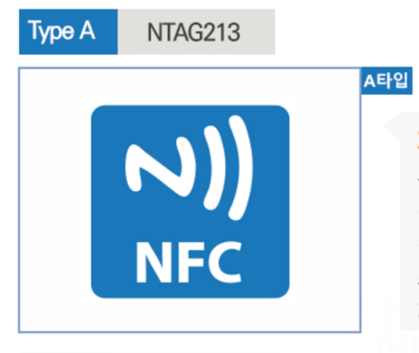

* 1. ***NFC Interface***

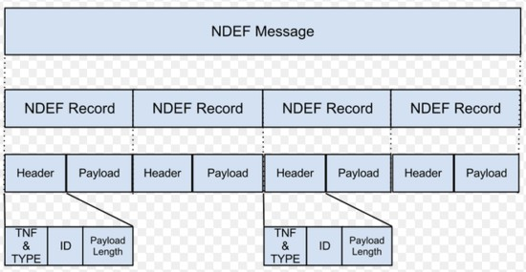We used the NDEF (NFC Data Exchange Format) to develop NFC interface. NFC tag is represented by several NDEF Message data. NDEF Message contains one or more NDEF records. Unlike RFID, NFC can read/write data and exchange data with other machines. We inserted user/item information in NDEF message. To register image on NFC, Encode bitmap image using base64encoding(string). But it had a problem of exceeding the capacity of the NFC. ResizeBase64Image didn’t work. It still over capacity. So, instead of registering an image directly with NFC, we stored image as string on DB and image fetch URL on NFC.

* 1. ***DB Design & Structure***

We used micro as the server and database, ubuntu + express + graphql + prisma.

GraphQL is a query language for the API, a server-side runtime that executes queries using the type system, over-fetching of existing REST APIs, and under-fetching problems (to complete one, solve the problem of multiple requests).

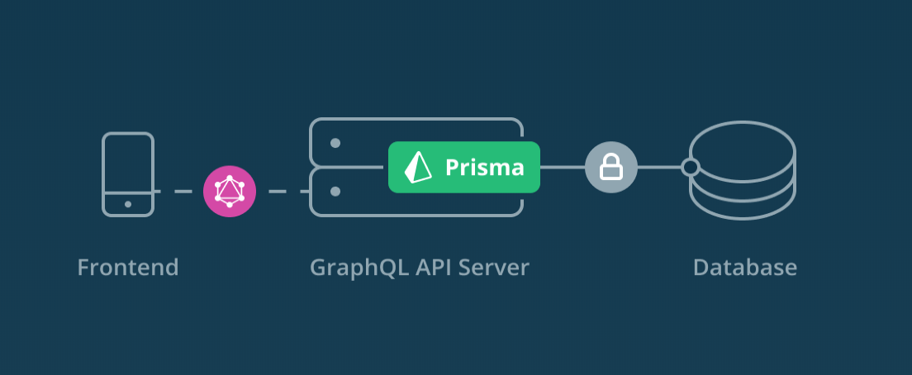Prisma is a GraphQL database proxy that turns our database into a GraphQL API. We could use the API as the basis for our own GraphQL server or connect directly from our frontend application. If we write only data model of GraphQL format, ORM client, model and Data Schema are generated automatically regardless of language and DBMS. Provides implementations of GraphQL and REST APIs. It provides easy administration of data by providing its own admin page.

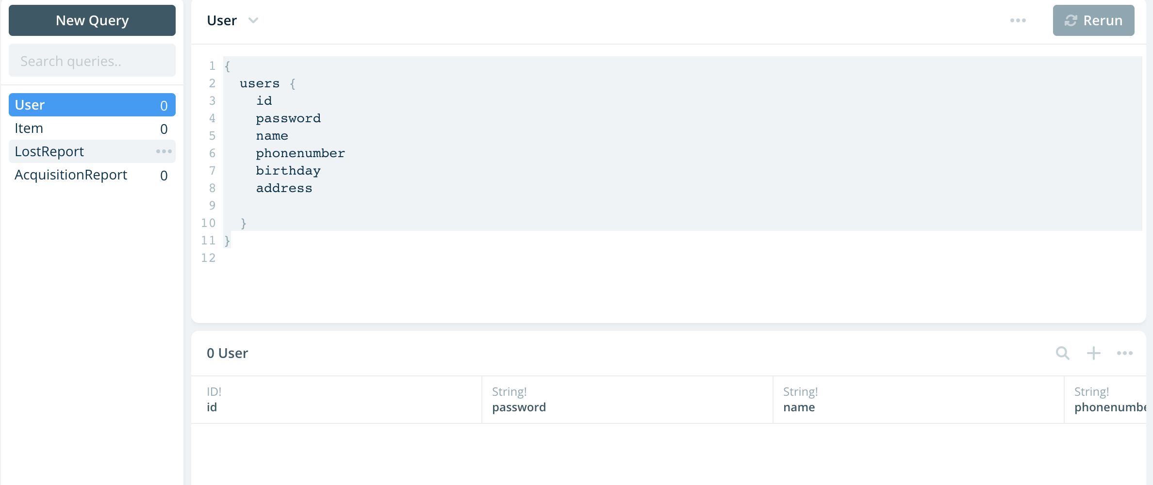

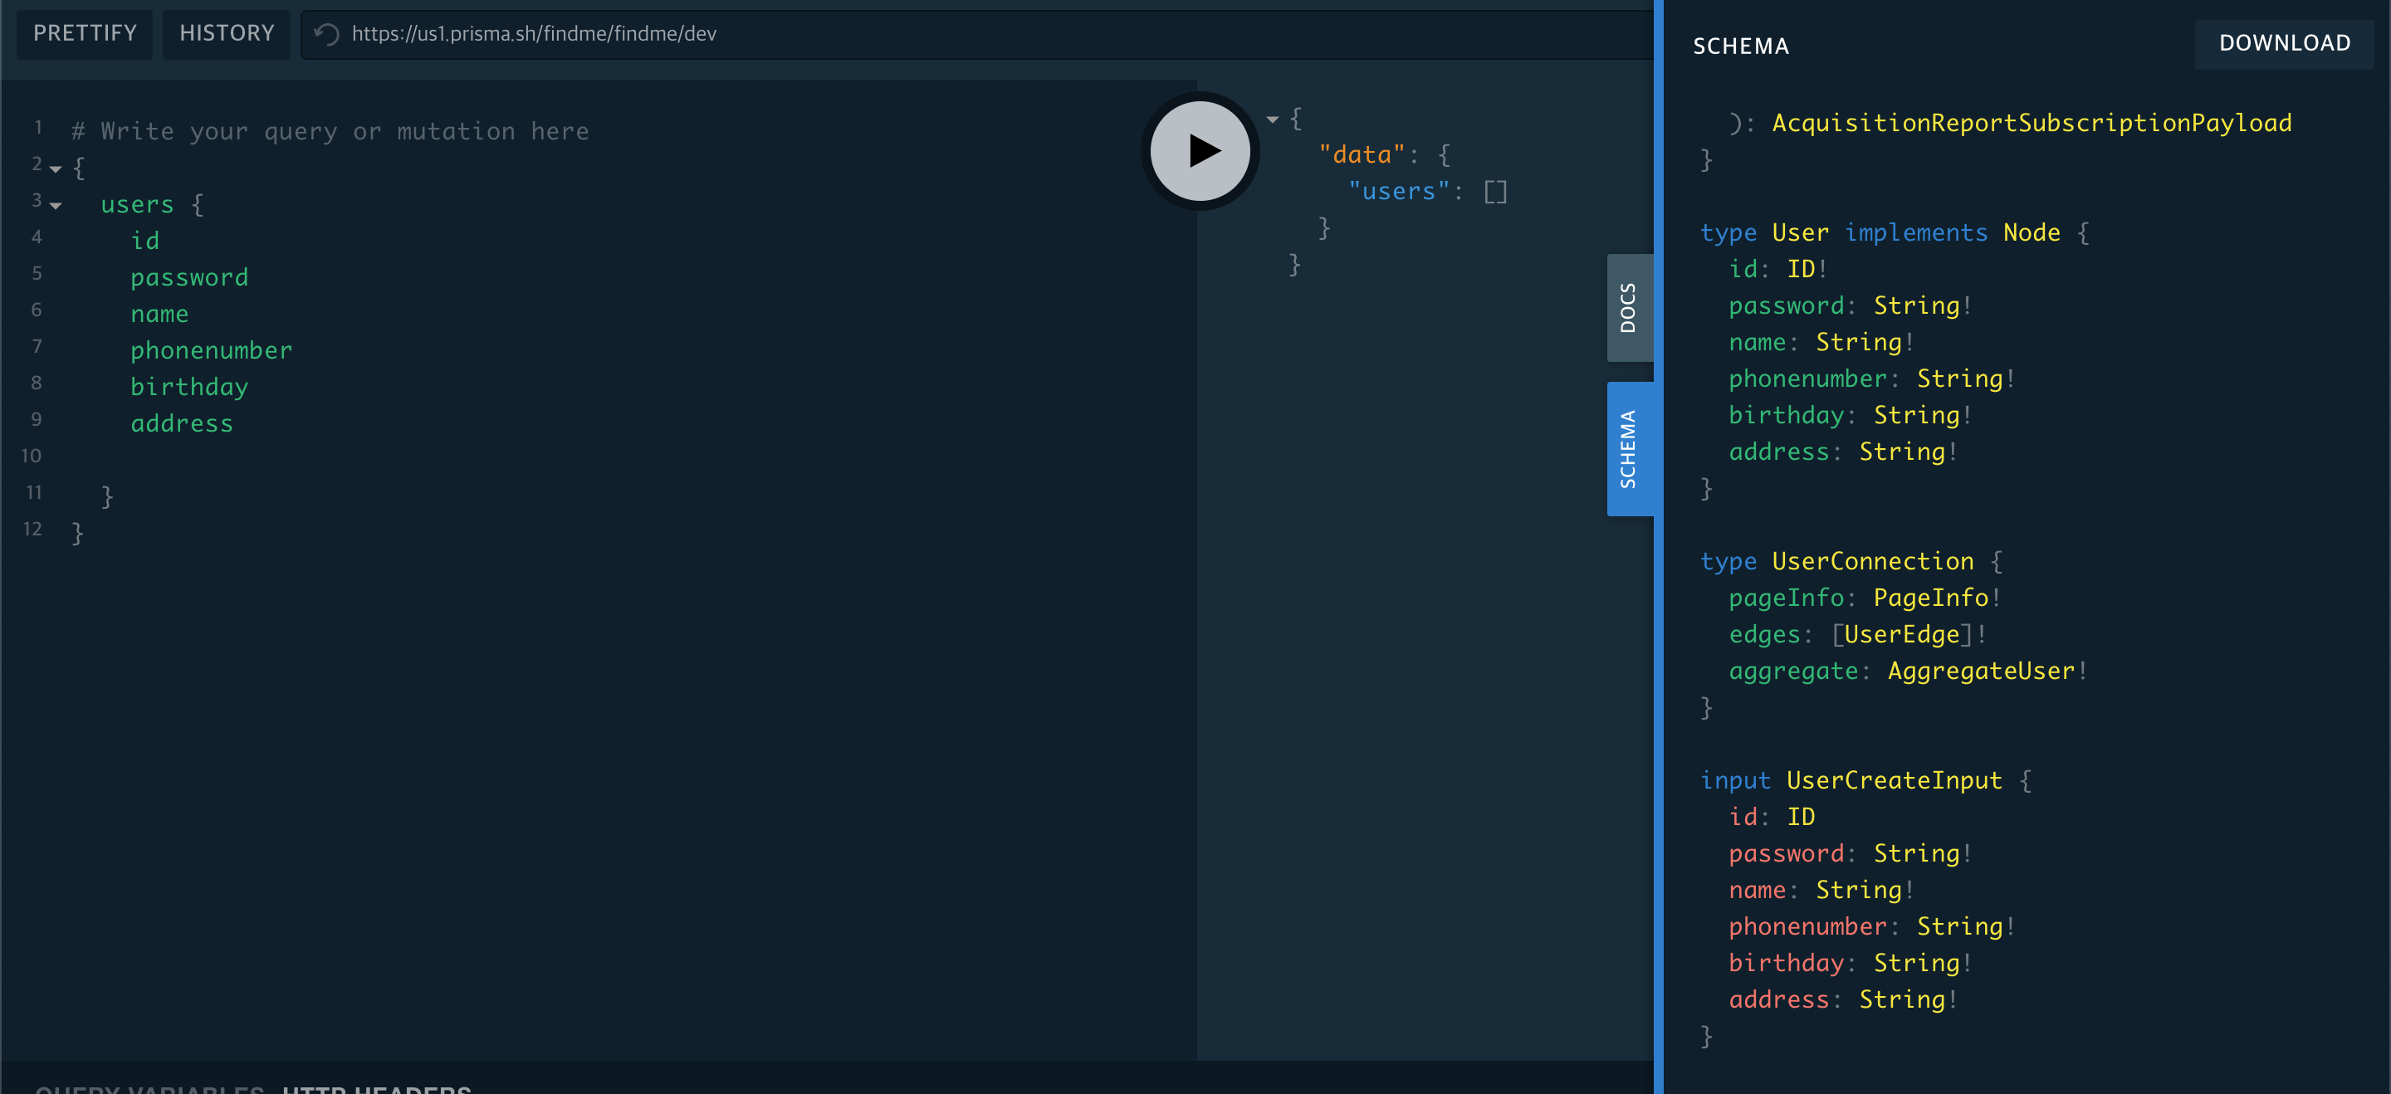

* 1. ***UI Design & Frontend***

we created the UI design of the application in proto.io. Based on the designed UI, we developed a frontend in xml in Android Studio.

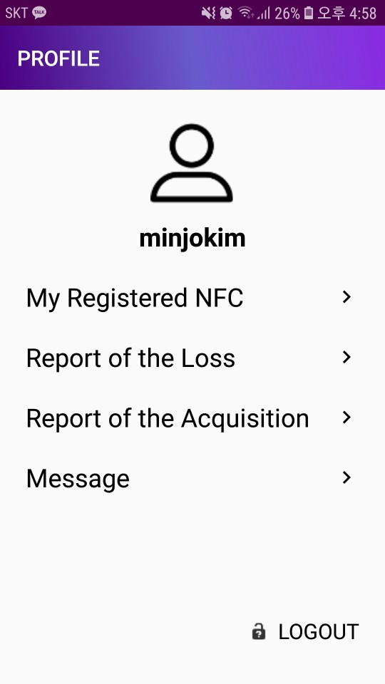

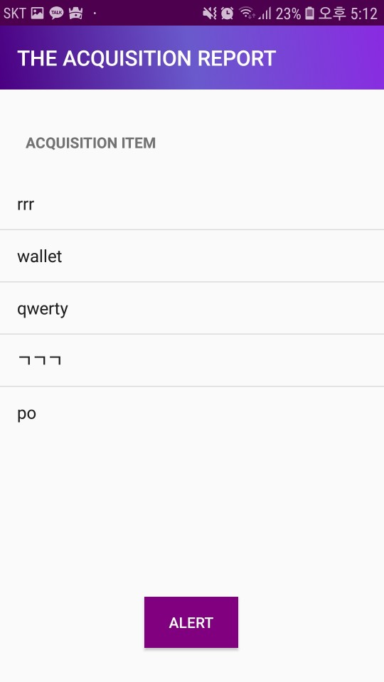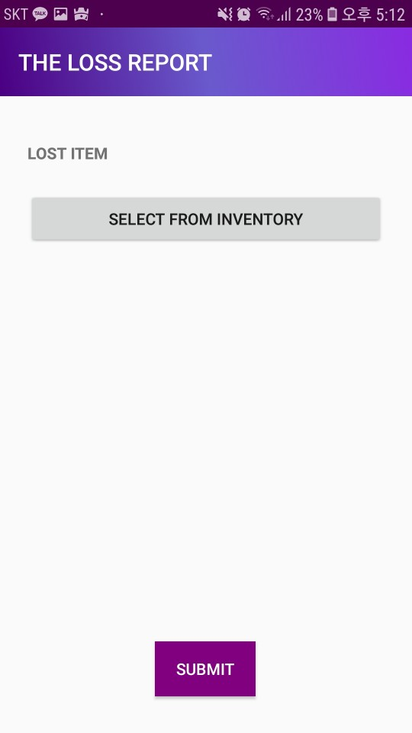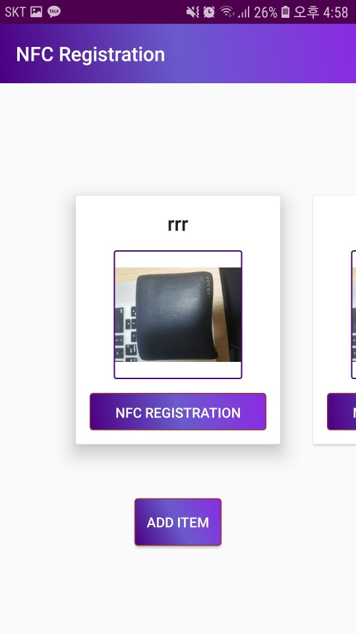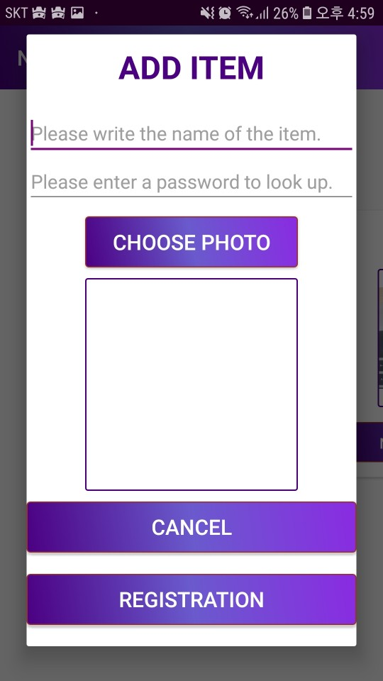

* 1. ***Alarm Service & Message System***

First of all, we used the Firebase database(Firebase Cloud Messaging) for alarm. The onMessageReceived is called, when the alarm is sent by the sending server. It then passes the message received from the server to send notification for alarm. After that, it creates and displays a notification in sendNotification.

After completing the alarm part, we used firebase's real-time database to access the message. The target is connected to the code. The goal is to send the message to the user who finds the missing object or has it sent to the user. To do this, send a message and send an alarm. Firebase is a document-structured database similar to the structure of NoSQL, and since duplicate primary keys are not generated, there is no protection against duplicate input from the beginning. Therefore, from the center's point of view, the id of the sender must be received and sent. In other words, the user sends the id to firebase at the same time as login, and proceeds with the configuration as if an empty chat room was created. When the center finds a user to find an object, the user inquires the id of the object to firebase and puts a message in the corresponding empty chat room. When you put a message and send an alarm at the same time, the lost user can check through the alarm and receive a message to receive a guide to find things.

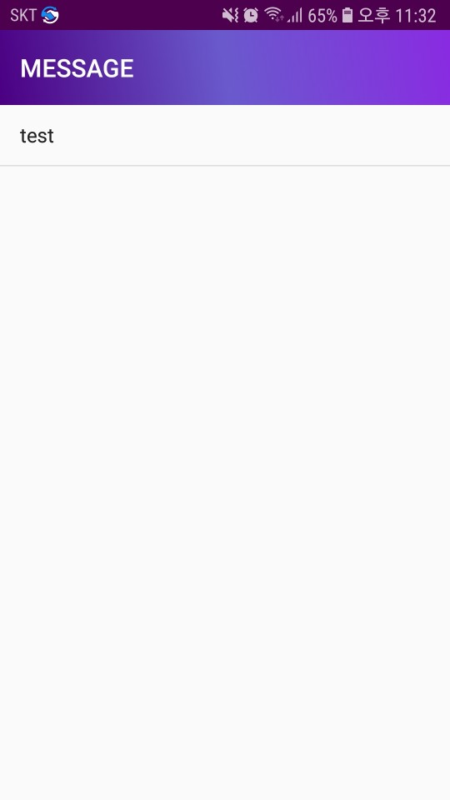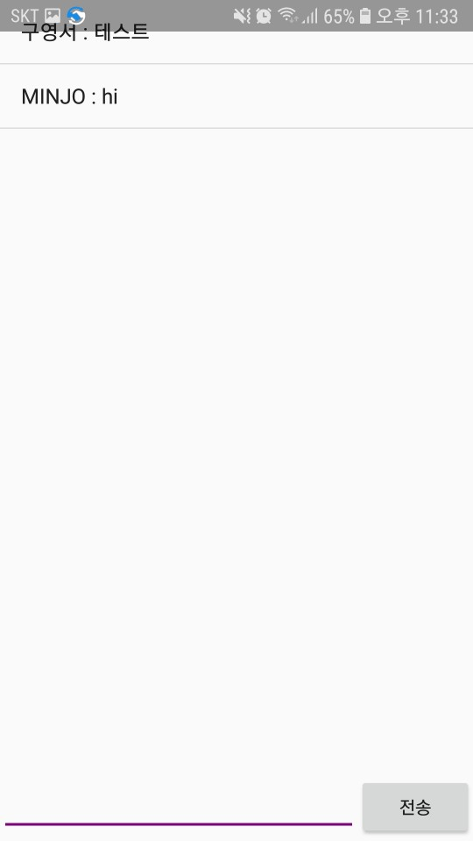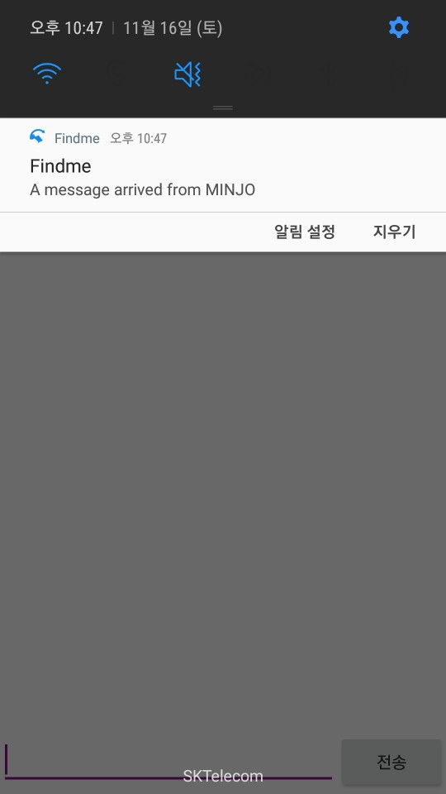

***5.Implementation***

**5.1 Implementation**

In order to implement the proposed solution, the core necessary is the NFC module. NFC stickers are available at low prices, and NFC readers can be replaced by Android. The user subscribes to the service(application) to register NFC. And the user writes the information to NFC through the Android application and then attaches the corresponding NFC sticker to his stuff.

If a lost item with an NFC sticker is registered at the Lost & Found Center, the officer can identify the owner's info by reading the NFC sticker on the lost item with the NFC reader(Android). Based on this identified information, lost-found process can be proceeded.

**5.2Problem & Solution**

We had three big problems when developing our application. The first is image recognition, the second is reducing the size of large images such as DSLR, and final one is security problem.

To register image on NFC, we encoded bitmap image using base 64encoding(string). But it exceeded the capacity of the NFC. We tried a different way which is resizeBase64Image. It also had a problem with exceeding capacity. Instead of registering an image directly with NFC, we changed the image to base64 and saved it in DB. Later when we load it as a string, it proceed base64 to image again(Storing image fetch URL on NFC).

For the big capacity of image problem, we tried to lower the capacity of image by base64 encoding. We used the similar way with the image recognition problem.

For the security problem, we used password for security of NFC information. Before adding the item, the user should enter password for security of NFC information with entering item name. This password is used to solve the security problem of overwriting NFC information.

***6.Result Comparison***

|  |  |
| --- | --- |
| **Midterm Demo** | **Final Demo** |
| * NFC analysis and purchase NFC sticker * Development environment configuration * DB design & implementation * UI Design * Implement core function through NFC interface * Data set : 5 (5 NFC Cards) * NFC read / write without error(100% of success) | * Develop all UI * Alarm * Message functions * Complete Android application * Test and debugging * Data set : 35 (5 NFC Cards + 30 NFC stickers) * NFC read /write without error(100% of success) |

|  |  |  |
| --- | --- | --- |
| ***Proposal*** | ***Implementation*** | ***Result*** |
| NFC analysis | NFC analysis | Complete |
| Purchase NFC Sticker | Purchase more stickers with different types (NTAG 213, NTAG 216) | Complete |
| Development environment configurations | Development environment configurations  (Android studio, sing up, sign in etc.) | Complete |
| DB design & implementation | DB design & implementation  (Prisma + graphql) | Complete |
| UI Design | UI Design  (Proto.io) | Complete |
| Implement core function through NFC interface | NFC Read / Write  (NDEF) | Complete |
| Develop UI | Develop all UI  (Frontend with xml) | Complete |
| Alarm system | Alarm system with firebase | Complete |
| Message function | Message function with Firebase real-time database | Complete |

***7.Time schedule***

|  |  |  |  |  |  |  |  |  |  |  |  |  |  |  |  |
| --- | --- | --- | --- | --- | --- | --- | --- | --- | --- | --- | --- | --- | --- | --- | --- |
|  | **WEEK** | | | | | | | | | | | | | | |
| **1** | **2** | **3** | **4** | **5** | **6** | **7** | **8** | **9** | **10** | **11** | **12** | **13** | **14** | **15** |
| **Project Selection** |  |  |  |  |  |  | **Medium Demo** | **Midterm Exam** |  |  |  |  |  | **Final Demo** | **Final Report** |
| **Proposal** |  |  |  |  |  |  |  |  |  |  |  |
| **NFC Purchase** |  |  |  |  |  |  |  |  |  |  |  |
| **Android Develop** |  |  |  |  |  |  |  |  |  |  |  |
| **UI Design** |  |  |  |  |  |  |  |  |  |  |  |
| **DB Design & Structure** |  |  |  |  |  |  |  |  |  |  |  |
| **NFC Interface** |  |  |  |  |  |  |  |  |  |  |  |
| **Front-end** |  |  |  |  |  |  |  |  |  |  |  |
| **NFC analysis** |  |  |  |  |  |  |  |  |  |  |  |
| **Alarm service** |  |  |  |  |  |  |  |  |  |  |  |
| **Message System** |  |  |  |  |  |  |  |  |  |  |  |
| **Test & Debugging** |  |  |  |  |  |  |  |  |  |  |  |  |  |  |  |

|  |  |
| --- | --- |
| ***KOO*** | ***WOO*** |
| ***KIM*** | ***COMMON*** |

No change in schedule after 5th modification of proposal.

***8.Conclusion***

Our team KKW developed the application to find lost items using NFC Sticker. User can use this application with any NFC sticker. In addition, NFC prices are very low, so hopefully it will be a chance for people to find a little more of their stuff through findme application.